Homework Assignment 5

CS696, Applied Computer Vision

Object Classification is a classification problem which tends to classify different objects like flowers, faces, fruits or any object we could imagine.

Object classification is the important task for the applications based on computer vision. It is the task of classifying objects from different categories of objects. It is useful to classify the objects in the result images and can be helpful in tasks such as object detection and tracking.

The basic procedure for creating an object classifier is:

* Acquire a labeled data set with images of the desired object.
* Partition the data set into a training set and a test set.
* Train the classifier using features extracted from the training set.
* Test the classifier using features extracted from the test set.

The 3 methods used in this assignment are:

**Histogram of Oriented Gradient (HOG):**

Histogram of Oriented Gradient is a feature descriptor used for the purpose of object detection. The technique counts occurrences of gradient orientation in localized portions of an image. Computation of HOG is usually expensive and there may be some time constraints. Here, the image is divided into small connected cells and a histogram of gradient directions is compiled for pixels in each cell. The concatenation of these histograms is called the descriptor. For improved accuracy, the local histograms can be contrast-normalized by calculating a measure of intensity across a larger region of the image called as block. This value is used to normalize all cells within the block. Since it operates on local cells, it is invariant to geometric and photometric transformations, except for object orientation. We have used ‘extractHOGFeatures’ to extract HOG features.

* **Code:**

% using histogram of gradient

x1=extractHOGFeatures(img);

x1=x1(x1 > 0.1);

features(1,:) = x1(1:128);

* **Results:**

**>> accuracy=0.355556**

**>> confMat**

**confMat =**

**10 11 9**

**8 8 14**

**7 8 15**

**>> accuracy=0.322222**

* **Failure Image of HOG:** These images were incorrectly classified by the algorithm. The test label and predicted labels are as follows:

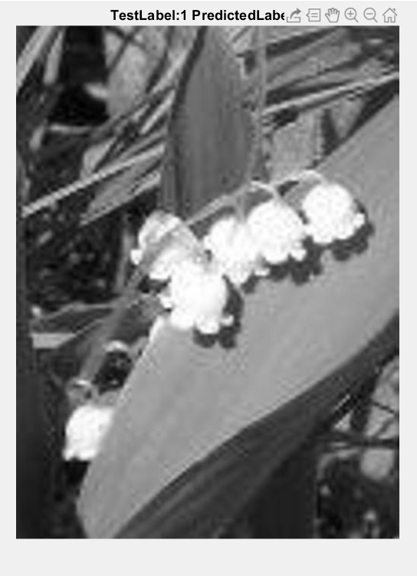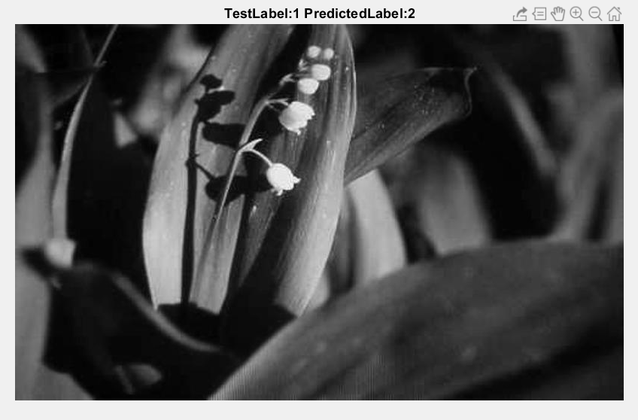

**Histogram of Color (HOC):**

A color histogram is a representation of the distribution of colors in an [image](https://en.wikipedia.org/wiki/Image). A color histogram can be represented as the number of pixels that have colors in each of a fixed list of color ranges. The color histogram can be built for any kind of color space, although it is specifically used for 3D spaces like RGB and HSV. The values of a color histogram are generated from statistics. They show the statistical distribution of colors and the essential tone of an image. In general, as the color distributions of the foreground and background difference increases, there might be a bimodal distribution in the histogram.

The imadjust(img) is used to map the intensity values in grayscale image from input image to new values in output image. By default, imadjust(img) saturates the bottom 1% and the top 1% of all pixel values. We then get the histogram of the adjusted image, and convert it into matrix of 1-128 to extract the features.

* **Code:**

%Using histogram of color

adjustedImg = imadjust(img, [0.0 1.0], [0.0 0.5]);

histImg = imhist(adjustedImg);

histImg = histImg(1:128);

histImg = histImg';

features(i, :) = histImg;

* **Results:**

**>> accuracy=0.366667**

**>> confMat**

**confMat =**

**0 0 30**

**1 0 29**

**0 0 30**

**>> accuracy=0.333333**

**Failure Image of HOC:** These images were incorrectly classified by the algorithm. The test label and predicted labels are as follows: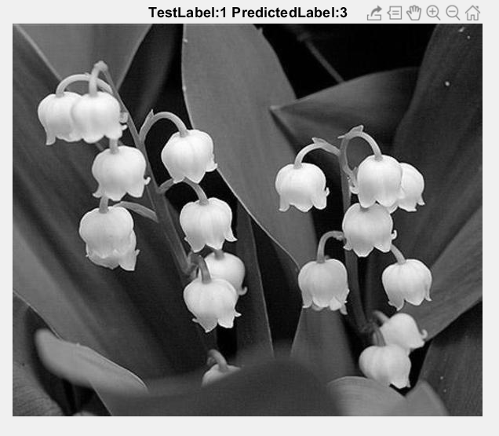

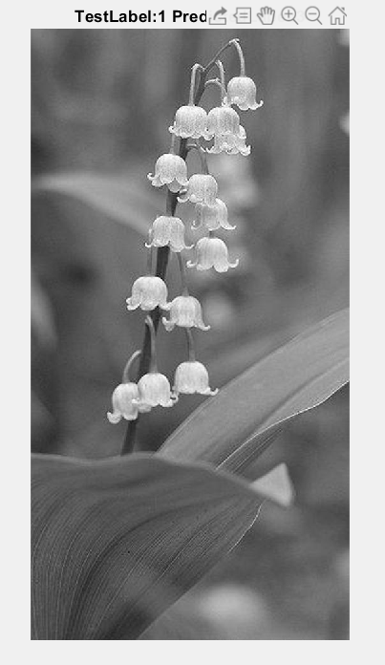

**SIFT-like SURF (Speeded Up Robust Features):**

It is inspired by SIFT (Scale Invariant Feature Transform). SURF is a feature descriptor to detect and describe local features in images. It can be used for tasks such as object recognition, image registration, classification or 3D reconstruction. The standard version of SURF is several times faster and much more robust than SIFT. To detect interest points, SURF uses an integer approximation of the determinant which can be computed with 3 integer operations using a precomputed integral image. SURF descriptors have been used to locate and recognize objects, people or faces, to reconstruct 3D scenes to track objects and to extract points of interest.

We use the method called ‘detectSURFFeatures’ to extract the SURF features.

* **Code:**

%Using SIFT(SURF) features

corner = detectSURFFeatures(img);

corSt = corner.selectStrongest(128);

[feature, vp] = extractFeatures(img,corSt);

f1 = sum(feature, 2).';

[m, n] = size(f1);

for j = 1:n

features(i,j) = f1(j);

end

* **Results:**

**>> accuracy=0.400000**

**>> accuracy=0.322222**

**>> confMat**

**confMat =**

**8 13 9**

**7 8 15**

**7 10 13**

**Failure Image of Sift-like SURF:** These images were incorrectly classified by the algorithm. The test label and predicted labels are as follows:

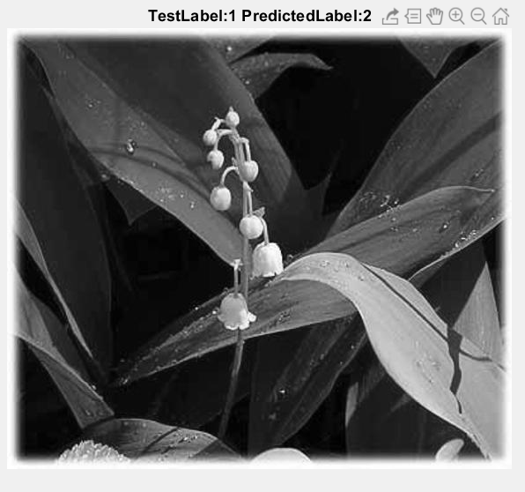

**Code for Failure Image Detection:**

imgSet = numel(arrTestID);

for i=1:imgSet

if(testLabels(i,7) ~= predictedLabels(1,7))

img = rgb2gray(read(flowerImageSet(3), arrTestID(i)));

figure;

imshow(img);

title(strcat('TestLabel: ', testLabels(i,7) , ' PredictedLabel: ',predictedLabels(i,7)));

break

end

end

**Conclusion:**

We performed the classification of images using SVM by 3 different methods:

1. Histogram of Gradients
2. Histogram of Colors
3. SIFT-like SURF features

The maximum accuracies achieved by each of the methods are:

Histogram of Gradients (HOG): Accuracy of **0**.**355556**

Histogram of Colors (HOC): Accuracy of 0.**366667**

SIFT-like SURF: Accuracy of 0.**400000**

On comparing the accuracies of all 3 of the methods, the accuracy was the least for the Histogram of Gradients (HOG) i.e. 0.355556. This was followed by a slightly better accuracy by the Histogram of Colors (HOC) with an accuracy of 0.366667. The best accuracy was the output of the SIFT-like SURF algorithm which resulted in the accuracy of about 0.400000.

This can be used to claim that the SURF algorithm can be considered as a better algorithm to give a better accuracy as compared to the other 2 algorithms.